Making Video and Voice Calls on Teams
Hi everyone, the following instructions will explain how to make video and voice calls on TEAMS.
When you are in your class/ tutor group Teams you should see this screen:
(We have used Purple Class as the example class)
Click on Class Notebook – as highlighted by the arrow.
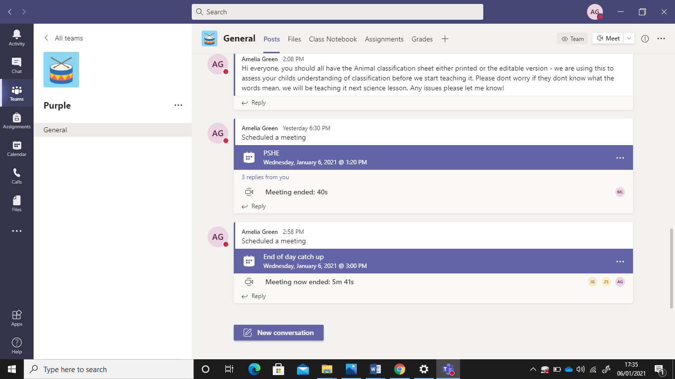
Click here to make a video or voice call.
This will open a page where you will see all your contacts.

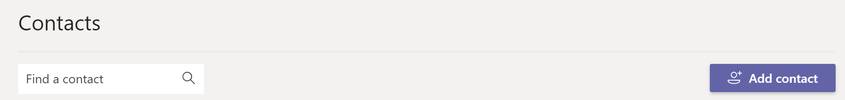
To add a new contact click here
Which will open up the following dialogue box.
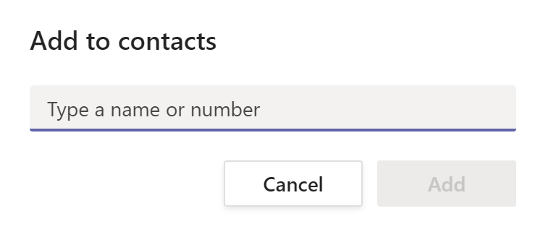
Follow on screen instructions and click add.

We have used Amelia’s address for an example.
You can now contact Amelia or anyone else you have contact details for via
- a message
- an email
- a video call
- a voice call

